**Guidelines for Papers**

**General Guidelines**

* Page Size: A4 (21 CM X 29.7 CM)
* Columns: Single
* Margins: Left 1.5", Right 1", Bottom 1", Top1"
* Line Spacing: 1.5
* Alignment: Justified
* Font: Times New Roman
* Words – Maximum 6000 words
* The second paragraph and the subsequent paragraphs under each new heading should start with the indentation.
* Paper should include sections of Abstract, Introduction, Previous Literature, Methodology, Results and Discussion, Conclusion and policy recommendations, if any; and Reference list

**TITLE OF THE PAPER (14pt, BOLD, CENTERED, UPPER CASE)**

Wijethunga AWGCN1 & Dayaratne DAI2 (11pt, Centered)

*Department (10pt, Centered, Italic)*

*University (10pt, Centered, Italic)*

*Email Address (10pt, Centered, Italic)*

**Abstract (Sentence case, 12pt, bold, Align to Centre)**

*Every submission of research article must begin with an abstract of a maximum of 250 words, followed by a maximum four (4) key words. The abstract should be a concise and clear presentation of the contents of paper it should be understandable by the reader.* *References to the literature and mathematical symbols / equations should not be included. The abstract should state the problem, purpose of the paper, approaches followed and also the results and conclusions. The abstract should be one paragraph. (11 Pt, justified, Italic, should be indented to 0.3 inches both sides.)*

**Key words:** *maximum 4 key words leave one blank line after the abstract*.

1. **Introduction (Heading should be Sentence case, 12pt, bold, Align to Left and sub headings should be numbered as 1.1, 1.2, etc. font size for subheadings 11pt,** **Sentence case and bold)**

The introduction of the paper may contain the problem, objectives and the contribution of the paper. The author should ensure that the paper is complete, grammatically correct and free from spelling mistakes. (11pt justified)

1. **Previous Literature (Sentence case, 12pt, bold, Align to Left)**

This section should contain minimum ten (10) previous studies and complete grammatically correct and free from spelling mistakes. (11pt justified). Authors are expected use paraphrasing, quotations appropriately throughout the chapter. Outcome of the literature review should be clearly stated.

1. **Methodology (Sentence case, 12pt, bold, Align to Left)**

Research methodology used should be very coherently stated including research approach sample, data collection and analysis tools should be included in this section. All equations should be serially numbered. Microsoft equation 3.0 should be used to insert equations. (11pt justified)

1. **Results and Discussion (Sentence case, 12pt, bold, Align to Left)**

This section is for reporting the results of the research and includes the discussion on finding of the research. (11pt justified)

Tables should be numbered sequentlly as 1, 2, and 3 with the title aligned centered above the Table. 10pt, bold, Sentence case must be used. (Font Size of table text 10pt)

Table 1: Test results of the unit root tests for the sample periods

|  |  |  |  |  |  |  |  |
| --- | --- | --- | --- | --- | --- | --- | --- |
| Variable | Series | 2005/2013 | | War Period | | Post war | |
| ADF | PP | ADF | PP | ADF | PP |
| *t stat* | *t stat* | *t stat* | *t stat* | *t stat* | *t stat* |
| GDP | Level | -6.57* | -21.48* | -8.61* | -14.14* | -1.74 | -10.69* |
|  | 1st | -6.21* | -52.28* | -11.95* | -41.77 | -8.17* | -37.78* |
| MCR | Level | -1.09 | -1.22 | -2.35 | -2.26 | -4.17* | -2.36 |
|  | 1st | -6.19* | -6.23* | 6.14* | 6.14* | -4.37* | 3.24** |
| STR | Level | -2.61 | -2.26 | -3.89* | -3.88* | -2.48 | 1.82 |
|  | 1st | -3.28** | -7.64* | -10.14* | -10.15 | -3.75** | 4.83* |
| TR | Level | -3.08* | -3.07* | -4.18* | -4.28* | -1.94 | 1.61 |
|  | 1st | -10.0* | -10.0* | -6.83* | -8.82* | -4.54* | 4.86* |
| COM | Level | -1.94 | -2.32 | -3.93* | -4.71* | -2.54 | 2.49 |
|  | 1st | -9.20* | -9.17* | -7.29* | -7.59* | -6.12* | 6.14* |

Figure should be numbered sequentially as 1, 2, and 3 with the title aligned centered below the Figure. (10pt, bold, Sentence case must be used)

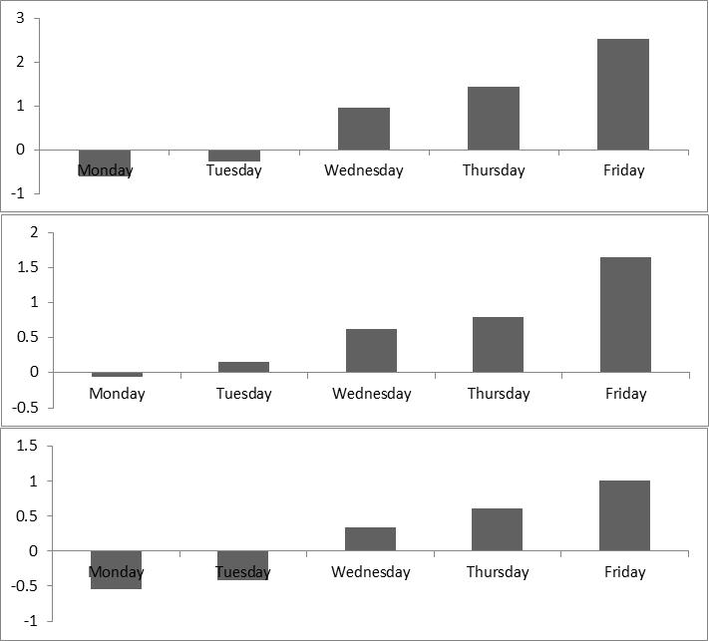

Figure 1: Average returns of selected indices for full sample period, war period and post war period.

1. **Conclusion (Sentence case, 12pt, bold, Align to Left)**

Conclusion should be clear and complete grammatically correct and free from typographical errors. (11pt justified)

**Reference (Sentence case, 12pt, bold, Align to Left)**

Reference should be in compliance with APA Method. First line should be hanging by 1.27 CM

Few examples for APA style referencing are listed below

Journal Articles:

Balachandran, B., Faff, R., & Theobald, M. (2008). Rights offerings, take-up, renounce ability, and underwriting status. *Journal of Financial Economics*, 89(2), 328-346.

Books

Alan, B., & Emma, B. (2007). Business Research Methods. *Oxford University Press,* New York.

Online sources

Israel, G. D. (2003). Determining sample size. Retrieved October 24, 2008, from <http://www.edis.ifas.ufl.edu>.

Dissertations

Krech, H. (2004). Training strategies for improving listeners' comprehension of foreign-accented speech (Doctoral dissertation). *University of Colorado*, Boulder.